Step to convert Oblivion textures to etc2 format (in a ktx container file)

Step 1:

Put your game data files somewhere separate. In this case I’ll put the Oblivion files (from Data) into c:\temp\Oblivion (note game of the year edition doesn’t work)

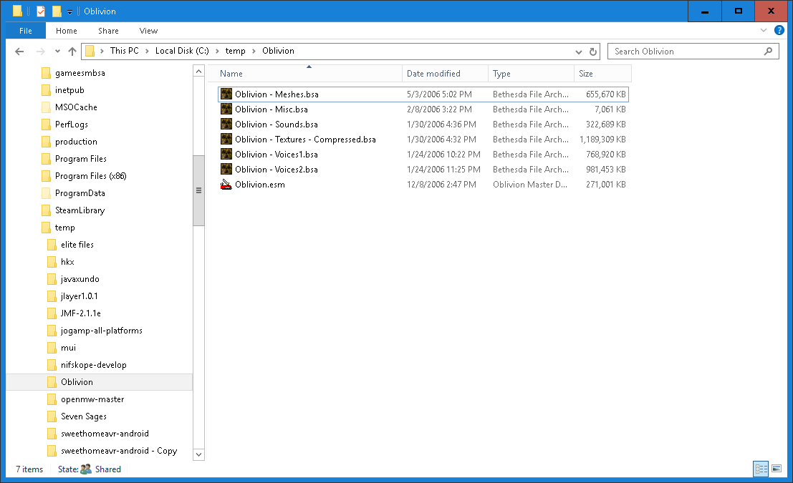

Step 2:

Extract all the files in this zip into that same directory or one next to it.

Step 3:

Extract the textures from the Oblivion – Textures – Compressed.bsa file

This requires the program Fomm or Fallout Mod Manager, install it from the exe I have provided in the zip with this doc file

Double click the “Oblivion – Textures – Compressed.bsa” file

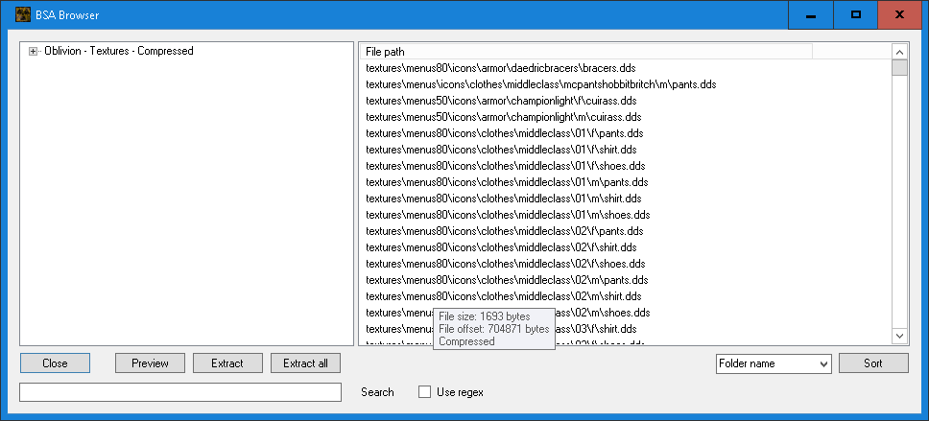

Select Extract all, select a folder in the working folder in my case called textures_original

After a long time you will see this folder full of .dds texture files, on windows 10 these should be easily viewable.

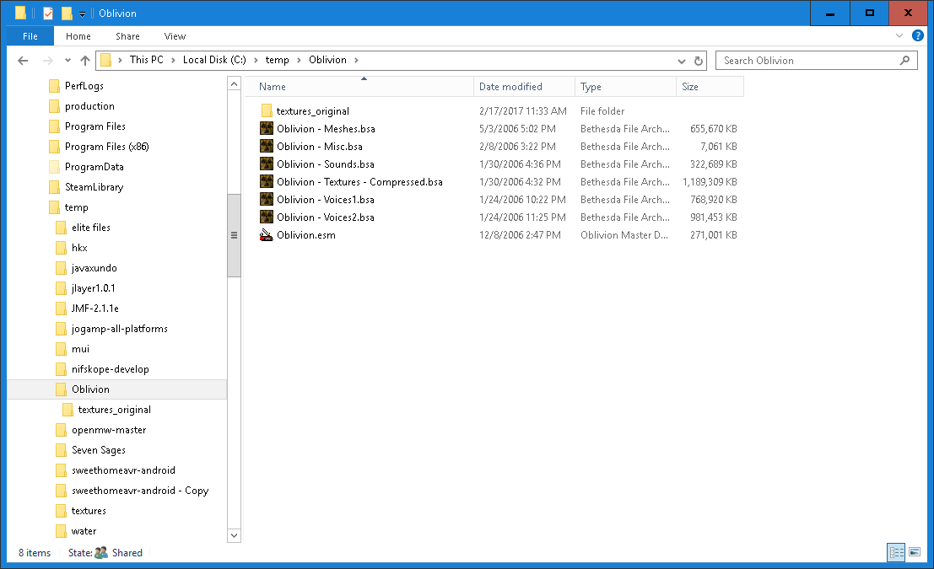

This texture_original should be 1.96 Gb in size

Step 4:

Convert files from dds to tga:

Drag the output folder onto the bat file “convert_folder 1 dds to tga.bat”

It will show you the output folder which should be fine, type y<enter> 4 times

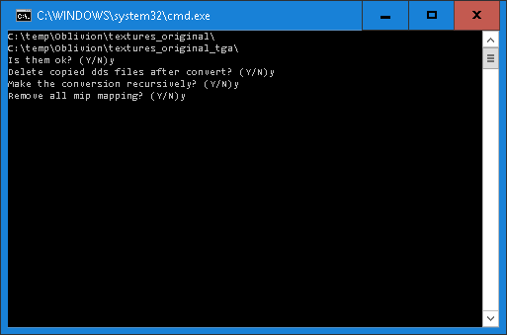

Long pause, heaps of crazy output, long time processing…

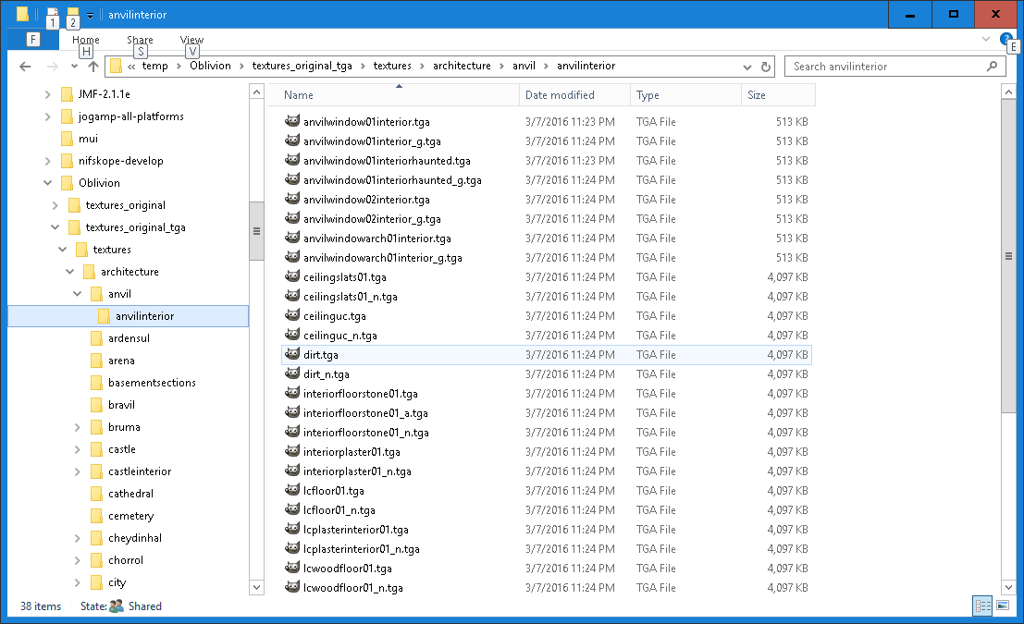

This folder should end up being 16.2Gb in size

Step 5:

Convert files from tga to ktx:

Drag the output folder of the previous step onto the bat file “convert_folder 2 tga to etc2 in ktx”.bat

This time only 3 y<enter>

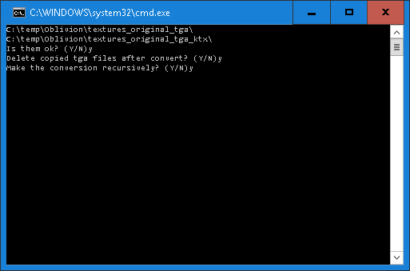

Another very long processing time

Ending with a new folder of 3.66 Gb

Now form start open the Fallout Mod Manager and select Tools->bsa creator

Select compress all in conbo box at lower left

Add Folders and select the textures_original_tga_ktx folder (not the sub folder of textures in it)

Notice the relative path includes the starting folder textures.

(I also had to move to my other drive hence the F:\... on the right)

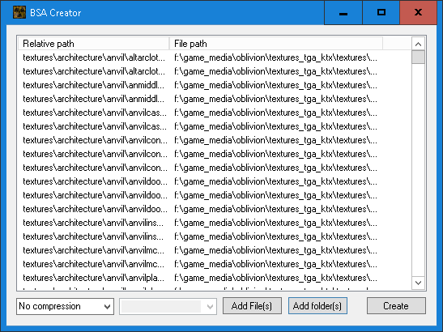

Press create and name it something like Oblivion – Textures – Compressed – ktx.bsa

Long pause…

Now put it and the esm file and the other bsa files (but not the original textures bsa file) onto your device.

Now in Red Mountain Tools use set game data file and pick the esm you just loaded, and you can now explore Oblivion.